Title

Omid Oftadeh¹, Behnaz Bakhshandeh^{1,} Masoumeh Souri², Hossein Maghsoumi², Fatemeh Ahmadi¹, Seyedeh Saba Nateghi³, Payam Zarrintaj⁴, Mohammad Reza Ganjali^{5,6}, Keyvan Malaie⁷, Nasser Masoumi²

- Department of Biotechnology, College of Science, University of Tehran, Tehran, Iran
- Department of Electronics, School of Electrical and Computer Engineering, College of Engineering, University of Tehran, Tehran, Iran
- Department of Microbiology, Faculty of Biology, University of Tehran, Tehran, Iran

- Center of Excellence in Electrochemistry, University of Tehran, Tehran, Iran
- Endocrinology & Metabolism Research Center, Tehran University of Medical Sciences, Tehran, Iran

Running title:
Abstract

Key words

Introduction
New advances in tissue engineering and regenerative medicine have brought hopes that it might be possible to fully repair damaged tissues and generate functional implants. Three key factors of tissue engineering are cells, scaffold, and stimulating factors such as growth factors and electrical induction that alter cell behavior and determine cell fate [1-3].
Exogenous electrical field (EF) as a stimulating factor has been vastly utilized for decades either in vivo or in vitro for clinical and tissue engineering purposes to induce diverse and sometimes contradictory cellular responses including differentiation, proliferation, alignment, adhesion, migration, and apoptosis [4-6]. Depending on the cell type, these cellular behaviors are manipulated by changing electrical stimulation (ES) parameters (amplitude and frequency) and regimens [7], as well as the methodology of ES delivery (direct, capacitive and inductive coupling) [1]. Although the effects of ES have been thoroughly investigated in the literature [8-10], the exact mechanisms are yet to be fully understood, regarding the complexity of the cell and EF nature [4, 5]. Nevertheless, almost all previous researches agree on the critical role of intracellular Ca²⁺ as an important second messenger in determining cellular fate and function and have demonstrated that the effect of ES on cells is mainly mediated by the entry of calcium ions into cells through voltage-gated calcium channels (VGCC) [7, 11, 12]. A possible explanation is that by applying ES, the cell membrane depolarizes which activates VGCCs and leads to an elevation in intracellular Ca²⁺ level [9, 13]. Ca²⁺ uptake further activates various signaling pathways such as Ca²⁺-calmodulin, mitogen-activated protein (MAP) kinase, and Rho A family-dependent pathways, followed by the activation of transcription factors and gene expression [14].
For functional differentiation, ES must be properly delivered to the seeded stem cells, in addition to mimicking their natural microenvironments. To this end, conductive biomaterials such as conductive polymers, metals, carbon materials and ceramics have been used to develop suitable scaffolds [1, 15]. Conductive polymers including poly (3,4-ethylene dioxythiophene), polypyrrole (PPy), and polyaniline are among excellent candidates due to advantages such as good electrical properties, ease of processing, high conductivity per weight ratio, and control of the electrical stimulus [12, 16, 17]. However, due to their poor biocompatibility, biodegradability and solubility, some modifications are required. Such modifications include but are not limited to combining with water-soluble and biocompatible materials, and using conductive oligomers instead of conductive polymers to enhance biodegradability [15, 18]. Oligoaniline-based biomaterials are promising candidates to fulfil the conditions of a proper scaffold. Our team recently constructed an electrospun scaffold made of oligoaniline blended with chitosan for bone tissue engineering [19].
Among various stem cell lineages, mesenchymal stromal/stem cells (MSCs) are widely used in tissue engineering. MSCs are multipotent stem cells, competent of differentiating into several cell lineages such as osteoblasts, adipocytes, chondrocytes, hepatocytes, cardiomyocytes, neurons, and muscle cells. In addition to differentiation, they have high capability of self-renewal and are easy to extract due to their ubiquity in the body [8, 20].
Since many previous works focused on characterizing hMSCs, their features are well documented in literature [21]. Effects of EF on MSCs have been extensively studied [22] and demonstrated that ion channels are highly expressed in their membrane [23, 24]. Efforts have been put to characterize these ion channels [7, 25], and their ionic currents have recently been mathematically formulated and modeled [26]. Results have confirmed the crucial role of Ca²⁺ levels and L-type calcium channels in the differentiation and proliferation [27]. Kawano et al. researched on Ca²⁺ channels and, along with Hou et al. reported a linkage between calcium oscillations and the differentiation in MSCs [12, 28].
Three different types of excitation (stimulation) for hMSCs have been observed, indicating that a random population of hMSCs is not uniform. hMSCs express different types of ion channels and might have distinct electrical behavior [25]. Based on experimental characterization [21, 25], five different functional ionic channels and currents have been identified in the plasma membrane of hMSCs:
- Delayed rectifier-like hEAG1 potassium channels (I_{Kdr})
- Calcium-activated potassium channels (I_{KCa})
- Tetrodotoxin (TTX)-sensitive sodium channels (I_{Na}),
- L-type calcium channels (I_{Ca,L}) and
- transient outward potassium channels (I_{Kto}).
The results of previous experimental and computational investigations have divided hMSCs into three distinct types based on their electrical behavior [12, 14]. Only I_{Kdr} and I_{KCa} pass through the first type of hMSCs membrane (type A). In addition to I_{Kdr} and I_{KCa}, outward currents (I_{Na} and I_{Ca,L}) pass through the second type of hMSCs membrane (type B). In Mayourian et al. [26], it is supposed that all hMSCs in type B express both sodium and calcium channels. However, this seems incorrect scrutinizing the experimental data [25], which states that inward currents coexist with outward currents in about 30% of hMSCs. At the same time, the presence of I_{Na} is confirmed in the same percentage of hMSCs, which means that all hMSCs in type B express sodium channels. On the other hand, independent investigations prove that I_{Ca,L} exists in only 15% of hMSCs [21, 25, 40], indicating that only half of hMSCs in type B express functional VGCCs.
In terms of materializing ES effect, the role of gap junctions needs to be considered. Gap junctions are cell-cell channels constructed from membrane proteins called connexins (e.g., Cx43, Cx45 and Cx40) [29]. They control the transfer of small metabolites and secondary messengers, and contribute to the propagation of calcium ions to adjacent cells [30]. According to Dilger et al., MSCs connections are gap junction-mediated to a large extend [29] and in a study, it was observed that the expression of Cx43 increased in a co-culture of MSCs and cardiac myocytes after electrical stimulation [31]. On the other hand, it has been demonstrated that ES only affects confluent cell cultures and no detectable impact has been observed in low-density cell cultures [32]. Given these facts, it can be concluded that gap junctions play a key role in mediating the ES effect. In other words, Ca²⁺ ions enter the hMSCs that have functional VGCCs in their membranes and are distributed to other cells through gap junctions.
Despite all the advances in tissue engineering, almost all the researches are still done based on try and error and the demand to adopt in silico approaches to get a better and more specific understanding of cellular response to electrical stimulation is increasing [33]. Equivalent circuit modelling is commonly used to simulate the changes of current and potential through the cell membrane in any biological system [34].
In this research, we aim to specify the effect that ES has on the cells. To this end, we synthesized aniline pentamer scaffold and proposed an electrical equivalent circuit for our delivery system (i.e., conductive scaffold) by fitting an equivalent circuit to electrochemical impedance spectroscopy (EIS) data. Subsequently, we modeled membrane potential changes and Ca²⁺ influx into the cells, via VGCCs and gap junctions. Additionally, an equivalent circuit was proposed for a 2D layer of hMSCs based on the previous experimental and computational data [25, 26]. Finally, the obtained equivalent circuits were conjugated to analyze the influence of circuits on each other.

Materials and Methods

Scaffold Synthesis and Characterization
Aniline pentamer was synthesized as described previously [35, 36]. Briefly, aniline dimer was reacted with succinic anhydride to synthesize carboxyl capped aniline dimer. Then, phenylenediamine reaction with carboxyl-capped aniline dimer resulted in aniline pentamer formation. Aniline pentamer was reacted with chitosan using the carbodiimide reactions to form chitosan-aniline pentamer. 5% wt chitosan-aniline pentamer solution and 2% wt polyethylene oxide (PEO) solution in aqueous 50% wt acetic acid were prepared and mixed so that the ratio of chitosan-aniline pentamer to PEO was 1:1 in the final solution. The prepared solution was electrospun at room temperature using 20 kV voltage, 20 cm distance between the nozzle (10 ml syringe) and the collector (aluminum drum), and 0.3 ml/h flow rate to construct a nanofibrous mat.

Electrochemical Impedance Spectroscopy
After drying the scaffold, cyclic voltammetry was performed to study the electrochemical properties of the mat using 1 M hydrochloric acid. Afterwards, to obtain an equivalent electrical circuit for the scaffold, electrochemical impedance spectroscopy was implemented. For this purpose, a 1×1 cm² sample of the scaffold, an Ag/AgCl electrode, and HCl solution (1M) as an electrolyte were used. A sinusoidal current with 380 mV amplitude was implemented, and the frequency was altered over a range of 10⁻³-10⁶ Hz. After obtaining the results, the Bode and Nyquist plots were drawn, and based on previous efforts to assign equivalent RC circuits to bioelectrodes [37], impedance data were fitted to an equivalent circuit using ZView software.

Electrical Simulation of the Scaffold
It is known that scaffold behaves like semiconductors, so herein, a set of wire models was applied. A full-fledged circuit model, taking into account the parasitic capacitor, resistor, and the inductance of copper wire, is shown (figure 1). It can be observed that these extra circuit elements are not located in a single physical point but are distributed over the length of the copper wire. This distribution is necessary when the length of the wire becomes more extensive than its width. Inductive effects can be ignored if the resistance of the wire is substantial. It is worth noting that some parasitic effects are inter wire, creating coupling effects between different copper wires that are not present in the original schematic.
The culture medium is an electrolyte containing ions that mediate the transmission of electric current to the cells, in which distance between cells and scaffold was 100 nm, and permittivity was 80 [38]. It was considered that there are parallel capacitors and resistance between cells and scaffold (figure 2), which were modeled with equations (3) and (4), respectively.
$$C=εε_{0}\frac{A}{d} (3)$$
$$R=ρ\frac{L }{A} (4)$$

Electrical Simulation of Single Cells
The membrane potential of a single cell can be generally modeled as:
${\frac{dV_{i}}{dt}=-\frac{1}{C_{m}}(I}_{tot,i}+I_{stim})$ i=A, B1, B2, C (1)
where V, t, and C_{m} stand for voltage, time, and membrane capacitance, respectively. I_{stim} is the stimulation current (in this work, the current that is induced by the current passing through the scaffold), and I_{tot,i} is total transmembrane current. I_{tot,i} for each type of hMSCs can be calculated as follow:
I_{tot,A}= I_{KCa}+ I_{Kdr}+ I_{L,A} (2)
I_{tot, B1}= I_{KCa}+ I_{Kdr}+ I_{Na}+ I_{L, B1} (3)
I_{tot, B2}= I_{KCa}+ I_{Kdr}+ I_{Na}+ I_{Ca,L}+ I_{L,B2} (4)
I_{tot,C}= I_{KCa}+ I_{Kto}+ I_{L,C} (5)
where I_{L,i} is the leakage current for other currents for type i that is not accounted for (i=A,B1,B2,C), which are calculated so that the resting membrane potential for hMSCs is about -35 mV [25, 26]. To calculate the aforementioned currents, equations and parameters in Mayourian et al. were used, which are provided in the supplementary information. I_{L,B1}, which was not considered before, is calculated according to Mayourian et al. [26].

Electrical Simulation for Seeded-Cells on The Scaffold
In the first step, a tetrad containing one cell from each type of hMSCs that are mutually connected via gap junctions was considered. For this system, the equation (1) is modified as below [39]:
${\frac{dV_{i}}{dt}=-\frac{1}{C_{m}}(I}_{tot,i}+I_{stim}+I_{gap,i})$ i=A, B1, B2, C (6)
where I_{gap,i} is the gap junction current between a cell and its adjacent cells. To calculate I_{gap,i}, it was modeled as a linear resistor with the following equation [39]:
$I_{gap,i}=\sum_{j=A,B1,B2,D}{I_{gap,ij}=}\sum_{j=A,B1,B2,D}{G_{gap}(V_{i}}-V_{j})$ i=A, B1, B2, C (7)
where G_{gap} is the gap junction conductance, j indices represent the adjacent cells from various types of hMSCs, and V is transmembrane voltage. This equation leads to equivalent circuits schematically (figure 2).

Results

Scaffold Synthesis and Characterization
FTIR and cyclic voltammetry (CV) were performed on chitosan-aniline pentamer, exhibiting two and three peaks, respectively. The FTIR peaks showed the presence of the incorporated materials. In more details, a peak at 1647 cm⁻¹ (corresponding to C=O stretching vibration) and a peak at 1570 cm⁻¹ (corresponding to quinoid ring) indicated the presence of chitosan and AP, respectively. On the other hand, the absence of a peak at 1718 cm⁻¹, corresponding to the COOH group at the end of the AP chain, indicated the formation of chitosan-grafted-AP.
SEM images confirmed the formation of smooth nanofibers with an approximate diameter of 200 nm and inter-connected porosity.

Electrochemical Impedance Spectroscopy
Electrochemical impedance spectroscopy was performed to assign an equivalent circuit to the scaffold, and the Nyquist plot of this system was drawn (figure 1). The Nyquist plots of such systems should be a semi-circle; however, an abrupt behavior was observed applying low frequencies to this system (frequencies below 10 MHz). That is because the measurement was performed in an acidic solution, and aniline-pentamer got involved in a redox reaction, and as a result, it was reduced to a leucoemeraldine state. The plotted Nyquist plot has maintained a semicircular state at a limited frequency rate. Still, due to chemical changes in the organic material of the scaffold, the data cannot be cited from a lower frequency, so we eliminated the data for frequencies below ten MHz and plotted the Nyquist plot and Bode plot (figure 1). Subsequently, the equivalent circuit fitted the experimental results (figure 2).
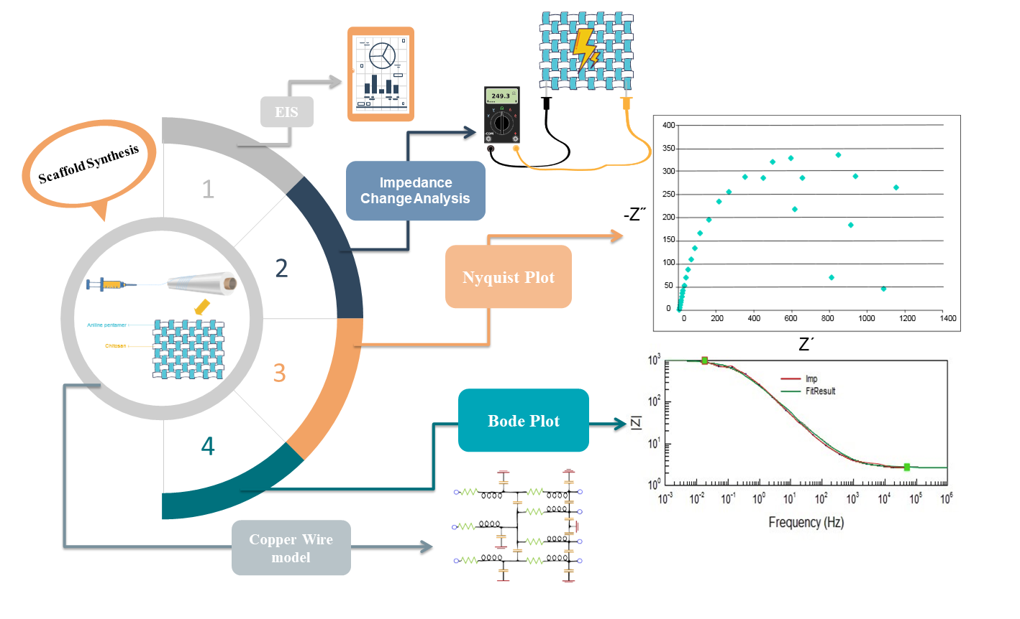
Figure 1: Scaffold detailed information. 1. Scaffold data were obtained through EIS measurements. 2. Electricity was applied to the scaffold to measure the impedance change by changing and increasing the applied frequency. EIS measurements were given to Z View software, and diagrams 3 and 4 were drawn. 3. Nyquist plot of the impedance of the scaffold model. The electrical behavior of the scaffold was disrupted in low frequencies (dispersed dots). The Nyquist plot should normally be drawn as a semicircle. Still, this system cannot be examined from one frequency onwards due to chemical changes in the organic material of the scaffold. 4. Bode plot of the impedance of the scaffold model. Nyquist and Bode plots of impedance magnitudes and phases measured after eliminating dots for the disrupted region (Y-Scale in Ohm). The copper wire model was used to represent the concept of distributed equivalent circuit schematically.

Electrical Simulation of the Scaffold
It was shown that the capacitor opens when the frequency is low (figure 1). Therefore, the scaffold model is equal to R_{s} in lower frequency ranges. After finding R_{s}, R_{d} can also be found considering the total resistance of the scaffold is R_{s}+R_{d}. The scaffold model with the resistance and the capacitor is demonstrated (figure 2). The design contains the source voltage, internal resistor, and external resistor for the setup (R-source) and the scaffold model.
Matlab and Hspice were utilized for measuring I_{stim} and membrane voltages. At first, the scaffold and cells were modeled together (figure 2). The scaffold contains N segments of cells, which are distributed. Regarding section 1.1, we take each cell equal to ∆Z, so ∆Z is 25μm (figure 2). Thus, the scaffold was modeled for a ∆Z. As can be seen here, there are cell, connection, and scaffold models.
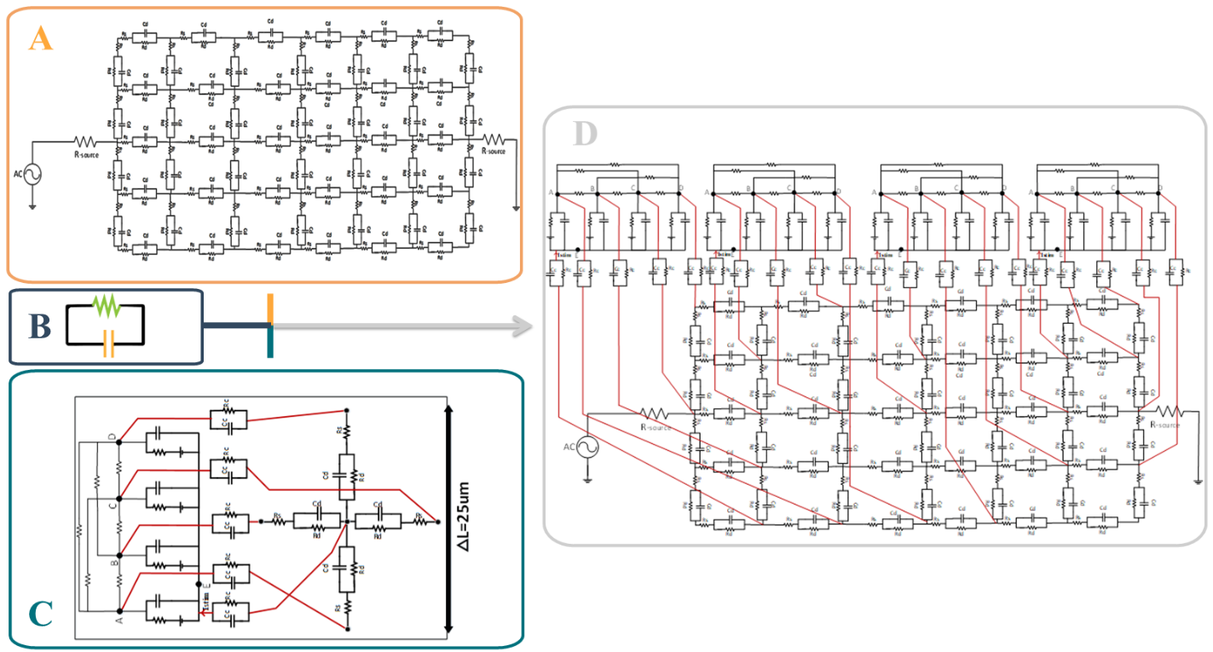
Figure 2: The figure is modeling the process and equivalent circuits to predict cell membrane potential changes over time. Resistance and capacitance are assumed for cell membranes, scaffolds, and cell culture media. The circuit of section A represents the distributed model of the scaffold with the voltage source, in which the cells are not shown. Section B is a model of cell culture media, which is a connection between cell and scaffold and is called a connector. In this model parallel capacitors and resistors were used to model the culture medium between the cells and the scaffold. The circuit of section C is a part of the scaffold model connected electrically to a tetrad of four different types of MSCs marked with A, B(B1), C(B2), D in the figure. The connectors are also present between cell types and the scaffold. The circuit of section D is the total model of the scaffold and the cells.

Electrical Simulation of Single Cells
In this work, we concentrated on the calculation of Ca2+ influx to the cells. Our team noticed that type B could be further divided into type B1 and B2 as subgroups, expressing only TTX-sensitive sodium channels and TTX-sensitive sodium channels and L-type calcium channels, respectively. Also, there is the third type of hMSCs, which is distinguished from the other two types by the two currents I_{KCa} and I_{Kto} (figure 4).

Electrical Simulation for Seeded-Cells on The Scaffold
As can be seen here, there are cell, connection, and scaffold models. In the first step, a tetrad containing one cell from each type of hMSCs was assumed mutually connecting via gap junctions, and the scaffold model was modeled for 25um in this system.
The equation (8) is formulated to calculate I_{stim}:
(8)
$$Istim=-\frac{1}{Z+5Z_{1}}\left(V_{EA}+V_{EB}+V_{EC}+V_{ED}\right)$$
$$Z=R_{S}+\frac{R_{d}}{1+R_{d}C_{d}S}$$
$$Z_{1}=\frac{R_{c}}{1+R_{c}C_{c}S}$$
In the first simulation, the effect of variation in the stimulation frequency on the membrane potential was examined (figure 3). In each simulation, the ES comprises DC stimulation with 2 V amplitude and AC stimulation with 0.1 V amplitude. The effect of the applied ES with 10, 100, 1000, and 10000 Hz frequencies on the membrane potential of various types of hMSCs was simulated. The results indicated that all types of hMSCs respond almost the same way to the frequency variation, where only 10000 Hz stimulation had a significantly more profound influence on membrane potential.
The effect of changing the amplitude of AC stimulation on the membrane potential was also investigated (figure 3). All stimuli comprised 2 V DC stimulation and AC stimulations with 100 Hz frequency, while the amplitudes of AC stimulations were 0.01, 0.1, 0.5, and 1 V. In this case, type B1 and B2 (with inward currents) acted similarly with a subtle difference in membrane potential alteration in response to amplitude changes. However, types A and C were more susceptible to amplitude changes, and higher amplitudes caused more depolarization. It is also worth mentioning that types B1 and B2 are more easily depolarized than types A and C.
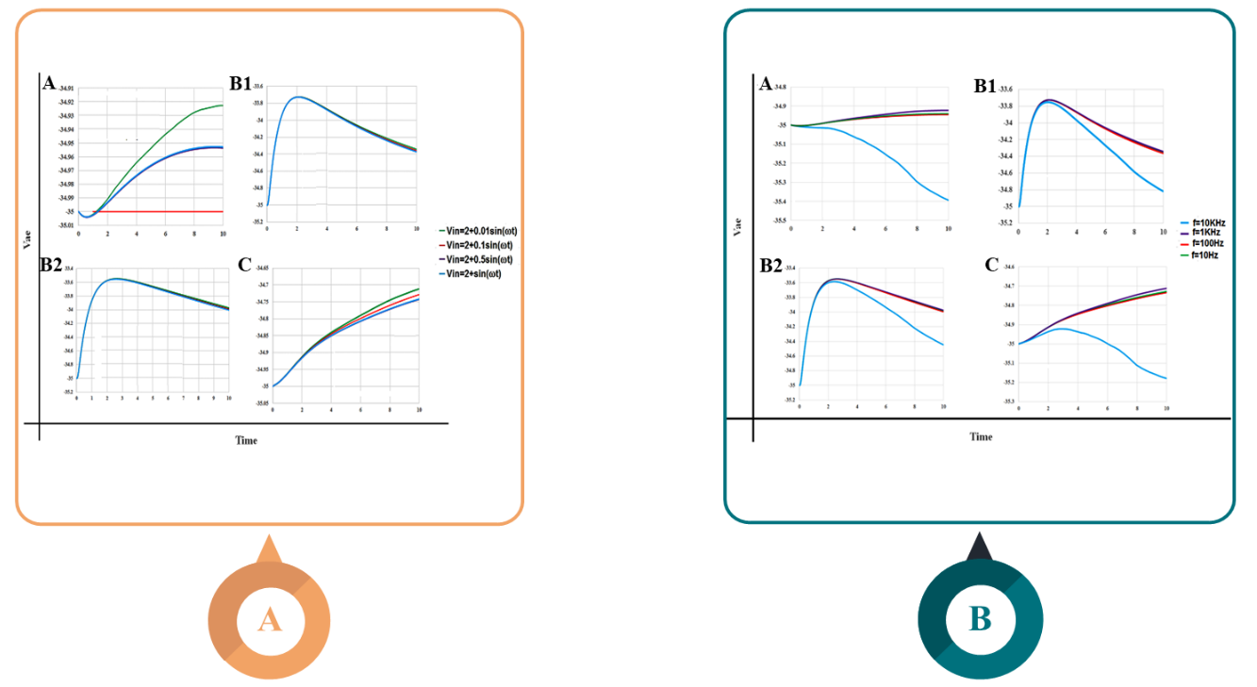
Figure 3: MSCs types detailed information. Diagrams in sections A and B show the types of MSCs. Diagrams in sections A and B show the effect of frequency change and Vin change, a sinusoidal function with a constant DC of 2, and a variable AC. Diagrams in section A show the effect of electrical stimulations with various amplitudes on different types of MSCs. Changing frequency in type A and, to some extent, type C caused a significant difference in membrane potential. Diagrams in section B show the effect of electrical stimulations with various frequencies on different types of MSCs. In all types of MSC, a significant difference in membrane potential was only achieved in 10 kHz frequency.

Discussion
This study successfully developed an equivalent circuit model for a system consisting of mesenchymal stem cells, culture media, and a conductive scaffold as components involved in electrical transduction. To achieve this goal, a chitosan-aniline pentamer scaffold was synthesized, and its structure and electroactivity were later determined by FTIR and CV [17-19]. EIS was then performed on the scaffold using frequencies more than 1 Hz to apply in tissue engineering [20]. Based on previous reports [12], the data were fitted to an equivalent circuit to represent the scaffold. For scaffold electrical simulation, all calculations were done assuming that the cell diameter is 25 um [41]. Thus, if a scaffold with a 2.5 cm area was used, the number of segments is equal to 1250 (N=1250). Additionally, equivalent circuits were modeled individually for cell and culture medium compartments.
The obtained circuits were finally conjugated to investigate further their impacts on each other (figure 2). To the best of our knowledge, our team was the first to combine three individual circuits to achieve a more comprehensive model for electrical induction research. This work complements previous studies that most of them relied on the medium resistance only and did not consider an equivalent capacitor for the culture medium [38, 41-44]. Kirkegaard et al. developed an equivalent circuit model combining cellular and medium resistance and capacitance; however, no scaffolds were used in the experiments and thus, not included in theoretical calculations [45]. Our proposed method can be used in any future work to investigate the electrical induction of scaffold-seeded cells by electric currents.
Three different types of excitation (stimulation) for hMSCs have been observed, indicating that a random population of hMSCs is not uniform. hMSCs express different types of ion channels and might have distinct electrical behavior [25]. Based on experimental characterization [21, 25], five different functional ionic channels and currents have been identified in the plasma membrane of hMSCs:
- Delayed rectifier-like hEAG1 potassium channels (I_{Kdr})
- Calcium-activated potassium channels (I_{KCa})
- Tetrodotoxin (TTX)-sensitive sodium channels (I_{Na}),
- L-type calcium channels (I_{Ca,L}) and
- transient outward potassium channels (I_{Kto}).
The results of previous experimental and computational investigations have divided hMSCs into three distinct types based on their electrical behavior [12, 14]. Only I_{Kdr} and I_{KCa} pass through the first type of hMSCs membrane (type A). In addition to I_{Kdr} and I_{KCa}, outward currents (I_{Na} and I_{Ca,L}) pass through the second type of hMSCs membrane (type B). In Mayourian et al. [26], it is supposed that all hMSCs in type B express both sodium and calcium channels. However, this seems incorrect scrutinizing the experimental data [25], which states that inward currents coexist with outward currents in about 30% of hMSCs. At the same time, the presence of I_{Na} is confirmed in the same percentage of hMSCs, which means that all hMSCs in type B express sodium channels. On the other hand, independent investigations prove that I_{Ca,L} exists in only 15% of hMSCs [21, 25, 40], indicating that only half of hMSCs in type B express functional VGCCs.
Among the shortcomings of our model, it is worth mentioning that a functional ion channel (i.e., inward rectifier potassium current) is not considered despite contributing to the membrane's resting potential [46]. Furthermore, due to limitations in performing cellular tests, we could not include impedance alterations caused by changes in cells’ morphology and distribution. Additionally, this model can be further modified by importing the electrodes as other transducing elements in the equivalent circuit model.
One of the novelties in this study was developing an electrophysiological model for the fourth type of MSCs in addition to previously introduced models for three types of MSCs [11]. Initially, five ionic currents distinguished in hMSCs were simulated based on experimental data (figure 4). Subsequently, total currents passing through each type of hMSCs were simulated, considering their functional ionic currents (figure 4). Later on, hMSCs were seeded on the scaffold and stimulated by a range of frequencies and voltage amplitudes [19].
There are five distinct currents in which inward currents (C and D demonstrating calcium and sodium currents) have similar patterns (figure 4). On the other hand, although distinguished between B1 and B2 cells, both types have similar simulated total currents passing through their membranes (figure 4). This similarity is perhaps why related papers consider three main induction types rather than four [26], yet this model supports experimental data [21, 23-25, 46]. Type B MSCs have different induction patterns than types A and C and are more easily depolarized (figure 3).
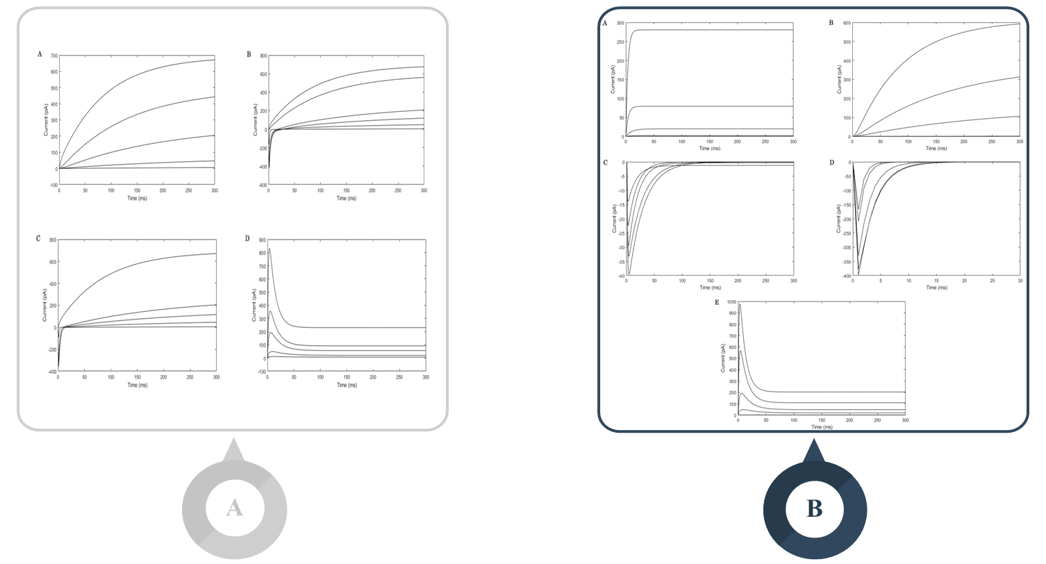
Figure 4: Diagrams in section A are schematic representations of five different ionic channels present in MSCs while maintaining membrane potential constant in each plot. In this section, graphs C and D are related to sodium and calcium channels, which have similar and inward currents. Diagrams in section B are schematic representations of total passing current through the membrane of four types of MSCs while maintaining membrane potential constant in each plot.
In recent years, scientists have taken approaches towards manipulating the behavior and destiny of stem cells, including MSCs by genetic and epigenetic alteration employing genome editing methods (such as CRISPR) [47], RNA interference [48], applying specific nutritional or drug regimens [49, 50] such as epigenetic drugs that stimulate DNA methylation [51], opening new opportunities to curing injuries and illnesses [52, 53]. In one study, some genes are introduced to be engineered for osteogenic differentiation of MSCs [54].
Taking into account the fact that type B of MSCs is easier to stimulate and with regards to the important role of L-VGCCs in the proliferation and osteogenic differentiation of MSCs [27, 55], It is suggested that in future work, depending on the purpose of the study, mesenchymal cells be manipulated with the mentioned techniques and stimulate or inhibit the expression of these channels. Similar work was done by Grajales et al., who elevated the expression of calcium channel subunits by applying bone morphogenetic protein-4 to the cells [45].

Conclusion and Future Remarks
In summary, we have demonstrated that our proposed equivalent circuit model can effectively simulate the electrical behavior of MSCs when exposed to a stimulatory current and is compatible with experimental data. In the way described in this work, the combination of individual circuits offers a more inclusive model, taking into account the role of each transducing component of the system. Additionally, by dividing type B of MSCs into B1 and B2 subtypes, a similar induction pattern was observed to distinguish between type A and C of MSCs.

Conflict of Interest
The authors declare no conflicts of interest.

Funding
The authors received no specific funding for this work.

References
1. Chen, C., et al., Electrical stimulation as a novel tool for regulating cell behavior in tissue engineering. Biomaterials research, 2019. 23(1): p. 1-12.
2. Bakhshandeh, B., et al., Tissue engineering; strategies, tissues, and biomaterials. Biotechnol Genet Eng Rev, 2017. 33(2): p. 144-172.
3. Abedi, A., et al., Concurrent application of conductive biopolymeric chitosan/polyvinyl alcohol/MWCNTs nanofibers, intracellular signaling manipulating molecules and electrical stimulation for more effective cardiac tissue engineering. Materials Chemistry and Physics, 2021. 258: p. 123842.
4. Leppik, L., et al., Electrical stimulation in bone tissue engineering treatments. European Journal of Trauma and Emergency Surgery, 2020. 46(2): p. 231-244.
5. Meng, S., et al., Electrical stimulation in tissue regeneration. Applied biomedical engineering, 2011: p. 37-62.
6. Babaie, A., et al., Synergistic effects of conductive PVA/PEDOT electrospun scaffolds and electrical stimulation for more effective neural tissue engineering. European Polymer Journal, 2020. 140: p. 110051.
7. Balint, R., N.J. Cassidy, and S.H. Cartmell, Electrical stimulation: a novel tool for tissue engineering. Tissue Engineering Part B: Reviews, 2013. 19(1): p. 48-57.
8. Thrivikraman, G., G. Madras, and B. Basu, Intermittent electrical stimuli for guidance of human mesenchymal stem cell lineage commitment towards neural-like cells on electroconductive substrates. Biomaterials, 2014. 35(24): p. 6219-6235.
9. Thrivikraman, G., S.K. Boda, and B. Basu, Unraveling the mechanistic effects of electric field stimulation towards directing stem cell fate and function: A tissue engineering perspective. Biomaterials, 2018. 150: p. 60-86.
10. Titushkin, I. and M. Cho, Regulation of cell cytoskeleton and membrane mechanics by electric field: role of linker proteins. Biophysical journal, 2009. 96(2): p. 717-728.
11. Jing, W., et al., Study of electrical stimulation with different electric-field intensities in the regulation of the differentiation of PC12 cells. ACS chemical neuroscience, 2018. 10(1): p. 348-357.
12. Hou, J., et al., Calcium Spike Patterns Reveal Linkage of Electrical Stimulus and MSC Osteogenic Differentiation. IEEE transactions on nanobioscience, 2018. 18(1): p. 3-9.
13. Zhang, J., et al., Electrical stimulation of adipose-derived mesenchymal stem cells in conductive scaffolds and the roles of voltage-gated ion channels. Acta biomaterialia, 2016. 32: p. 46-56.
14. Titushkin, I., et al., Physicochemical control of adult stem cell differentiation: shedding light on potential molecular mechanisms. Journal of Biomedicine and Biotechnology, 2010. 2010.
15. Zarrintaj, P., et al., Oligoaniline-based conductive biomaterials for tissue engineering. Acta biomaterialia, 2018. 72: p. 16-34.
16. Balint, R., N.J. Cassidy, and S.H. Cartmell, Conductive polymers: Towards a smart biomaterial for tissue engineering. Acta biomaterialia, 2014. 10(6): p. 2341-2353.
17. Cheng, H., et al., Electrical Stimulation Promotes Stem Cell Neural Differentiation in Tissue Engineering. Stem Cells International, 2021. 2021.
18. Liu, Y., et al., Synthesis and characterization of novel biodegradable and electroactive hydrogel based on aniline oligomer and gelatin. Macromolecular bioscience, 2012. 12(2): p. 241-250.
19. Oftadeh, M.O., et al., Sequential application of mineralized electroconductive scaffold and electrical stimulation for efficient osteogenesis. Journal of Biomedical Materials Research Part A, 2018. 106(5): p. 1200-1210.
20. Via, A.G., A. Frizziero, and F. Oliva, Biological properties of mesenchymal stem cells from different sources. Muscles, ligaments and tendons journal, 2012. 2(3): p. 154.
21. Heubach, J.F., et al., Electrophysiological properties of human mesenchymal stem cells. The Journal of physiology, 2004. 554(3): p. 659-672.
22. Dawson, J., et al., A General Theoretical Framework to Study the Influence of Electrical Fields on Mesenchymal Stem Cells. Frontiers in bioengineering and biotechnology, 2020. 8.
23. Park, K.S., et al., Diversity of ion channels in human bone marrow mesenchymal stem cells from amyotrophic lateral sclerosis patients. The Korean Journal of Physiology & Pharmacology, 2008. 12(6): p. 337-342.
24. Li, G.-R. and X.-L. Deng, Functional ion channels in stem cells. World journal of stem cells, 2011. 3(3): p. 19.
25. Li, G.R., et al., Characterization of ionic currents in human mesenchymal stem cells from bone marrow. Stem cells, 2005. 23(3): p. 371-382.
26. Mayourian, J., et al., Modeling electrophysiological coupling and fusion between human mesenchymal stem cells and cardiomyocytes. PLoS computational biology, 2016. 12(7): p. e1005014.
27. Wen, L., et al., L-type calcium channels play a crucial role in the proliferation and osteogenic differentiation of bone marrow mesenchymal stem cells. Biochemical and biophysical research communications, 2012. 424(3): p. 439-445.
28. Kawano, S., et al., Characterization of Ca2+ signaling pathways in human mesenchymal stem cells. Cell calcium, 2002. 32(4): p. 165-174.
29. Dilger, N., et al., Gap junction dependent cell communication is modulated during transdifferentiation of mesenchymal stem/stromal cells towards neuron-like cells. Frontiers in cell and developmental biology, 2020. 8: p. 869.
30. Toyofuku, T., et al., Intercellular calcium signaling via gap junction in connexin-43-transfected cells. Journal of Biological Chemistry, 1998. 273(3): p. 1519-1528.
31. Wen, L., et al., Mild electrical pulse current stimulation upregulates S100A4 and promotes cardiogenesis in MSC and cardiac myocytes coculture monolayer. Cell biochemistry and biophysics, 2013. 65(1): p. 43-55.
32. Mcleod, K.J., et al., Electric fields modulate bone cell function in a density‐dependent manner. Journal of Bone and Mineral Research, 1993. 8(8): p. 977-984.
33. Sah, M., J. Sadanand, and K. Pramanik, Computational approaches in tissue engineering. Int J Comput Appl, 2012. 27: p. 13-20.
34. Ramos, A., A. Raizer, and J.L. Marques, A new computational approach for electrical analysis of biological tissues. Bioelectrochemistry, 2003. 59(1-2): p. 73-84.
35. Zarrintaj, P., et al., A Novel Electroactive Agarose-Aniline Pentamer Platform as a Potential Candidate for Neural Tissue Engineering. Scientific reports, 2017. 7(1): p. 17187.
36. Atoufi, Z., et al., A Novel Bio Electro Active Alginate-Aniline Tetramer/Agarose Scaffold for Tissue Engineering: Synthesis, Characterization, Drug Release and Cell Culture Study. Journal of Biomaterials Science, Polymer Edition, 2017(just-accepted): p. 1-43.
37. Hong, S.-Y. and S.-M. Park, Electrochemistry of conductive polymers 40. Earlier phases of aniline polymerization studied by fourier transform electrochemical impedance spectroscopy. The Journal of Physical Chemistry B, 2007. 111(33): p. 9779-9786.
38. Cho, S., Electrical impedance analysis of cell growth using a parallel RC circuit model. BioChip Journal, 2011. 5(4): p. 327-332.
39. MacCannell, K.A., et al., A mathematical model of electrotonic interactions between ventricular myocytes and fibroblasts. Biophysical journal, 2007. 92(11): p. 4121-4132.
40. Kawano, S., et al., Characterization of Ca 2+ signaling pathways in human mesenchymal stem cells. Cell calcium, 2002. 32(4): p. 165-174.
41. Cho, S. and H. Thielecke, Electrical characterization of human mesenchymal stem cell growth on microelectrode. Microelectronic Engineering, 2008. 85(5-6): p. 1272-1274.
42. Hildebrandt, C., et al., Detection of the osteogenic differentiation of mesenchymal stem cells in 2D and 3D cultures by electrochemical impedance spectroscopy. Journal of biotechnology, 2010. 148(1): p. 83-90.
43. Low, K., et al., Physico-electrochemical characterization of pluripotent stem cells during self-renewal or differentiation by a multi-modal monitoring system. Stem cell reports, 2017. 8(5): p. 1329-1339.
44. Tonello, S., et al., Impedance-based monitoring of mesenchymal stromal cell three-dimensional proliferation using aerosol jet printed sensors: A tissue engineering application. Materials, 2020. 13(10): p. 2231.
45. Kirkegaard, J., et al., Study of paclitaxel-treated HeLa cells by differential electrical impedance flow cytometry. Biosensors, 2014. 4(3): p. 257-272.
46. Park, K.S., et al., Functional expression of ion channels in mesenchymal stem cells derived from umbilical cord vein. Stem Cells, 2007. 25(8): p. 2044-2052.
47. Gerace, D., et al., CRISPR-targeted genome editing of mesenchymal stem cell-derived therapies for type 1 diabetes: a path to clinical success? Stem Cell Research & Therapy, 2017. 8(1): p. 1-10.
48. Benoit, D.S. and M.E. Boutin, Controlling mesenchymal stem cell gene expression using polymer-mediated delivery of siRNA. Biomacromolecules, 2012. 13(11): p. 3841-3849.
49. Vecellio, M., et al., In vitro epigenetic reprogramming of human cardiac mesenchymal stromal cells into functionally competent cardiovascular precursors. PloS one, 2012. 7(12): p. e51694.
50. Zahanich, I., et al., Molecular and functional expression of voltage‐operated calcium channels during osteogenic differentiation of human mesenchymal stem cells. Journal of Bone and Mineral Research, 2005. 20(9): p. 1637-1646.
51. Govarthanan, K., et al., DNA methylation microarray uncovers a permissive methylome for cardiomyocyte differentiation in human mesenchymal stem cells. Genomics, 2020. 112(2): p. 1384-1395.
52. Damasceno, P.K.F., et al., Genetic engineering as a strategy to improve the therapeutic efficacy of mesenchymal stem/stromal cells in regenerative medicine. Frontiers in Cell and Developmental Biology, 2020. 8: p. 737.
53. Hodgkinson, C.P., et al., Genetic engineering of mesenchymal stem cells and its application in human disease therapy. Human gene therapy, 2010. 21(11): p. 1513-1526.
54. Hong, D., et al., Genetically engineered mesenchymal stem cells: the ongoing research for bone tissue engineering. The Anatomical Record: Advances in Integrative Anatomy and Evolutionary Biology, 2010. 293(3): p. 531-537.
55. Tan, Y.z., et al., L‐type voltage‐gated calcium channels in stem cells and tissue engineering. Cell proliferation, 2019. 52(4): p. e12623.

Graphical Abstract
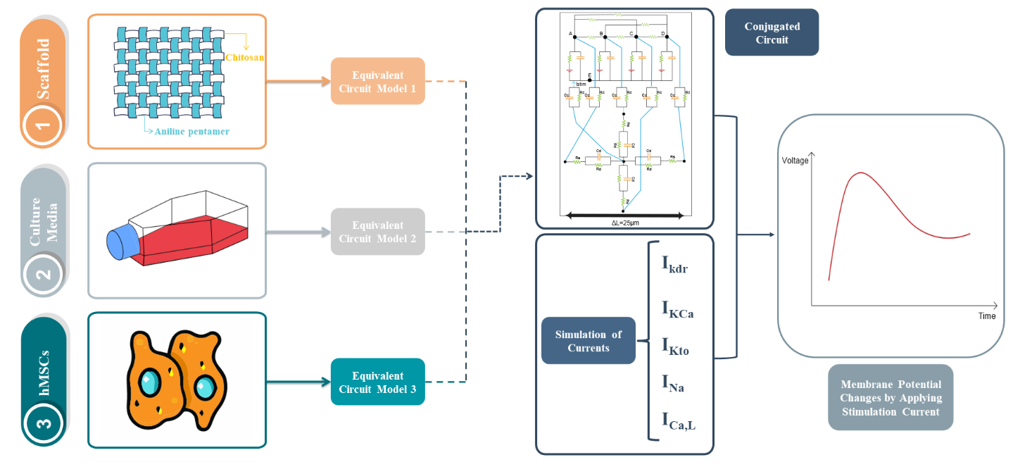
The three main components, scaffold, MSCs, and culture medium, were modeled into equivalent circuit models 1, 2, and 3. These models were put into a general model to take into account their relationships with each other. In this total model, the connections of four cell types A, B(B1), C (B2), and D to each other are shown, and an impedance is considered for each of their membranes. Then, these MSCs are shown to be connected to their culture medium and scaffold. Electrical induction is then applied to the cells and affects their ion channels to evaluate the membrane voltage changes over time. With this modeling and resulted diagrams, it is possible to predict how the calcium channels behave and whether they are open or closed with different applied current strengths.

Address correspondence to: Behnaz Bakhshandeh, Department of Biotechnology, College of Science, University of Tehran, P.O. Box: 14155-6455, Tehran, Iran. Tel: +98(21)66491622. Fax: +98-21-66413835. E-mail: b.bakhshandeh@ut.ac.ir
Address co-correspondence to: Nasser Masoumi, Department of Electronics, School of Electrical and Computer Engineering (ECE), College of Engineering, University of Tehran, P. O. Box: 14395-515, Tehran, Iran. Tel: +98(21) 82084356. Fax: +98-21- 82084356. E-mail: nmasoumi@ut.ac.ir

